**Experiment No:** 5  **Date:** 10/04/2021

**Aim:** Implementation of Knapsack Problem

(Greedy Approach) and obtain its step count

**Theory:**

**GREEDY METHOD**

* A greedy algorithm, as the name suggests, always makes the choice that seems to be the best at that moment.
* This means that it makes a locally-optimal choice in the hope that this choice will lead to a globally-optimal solution.

**ADVANTAGES AND DISADVANTAGES OF GREEDY METHOD**

* It is quite easy to come up with a greedy algorithm (or even multiple greedy algorithms) for a problem.
* Analysing the run time for greedy algorithms will generally be much easier than for other techniques (like Divide and conquer).
* For the Divide and conquer technique, it is not clear whether the technique is fast or slow.
* This is because at each level of recursion the size of gets smaller and the number of sub-problems increases.
* The difficult part is that for greedy algorithms you have to work much harder to understand correctness issues.
* Even with the correct algorithm, it is hard to prove why it is correct.
* Proving that a greedy algorithm is correct is more of an art than a science.

**GREEDY METHOD SUGGESTS**

* Algorithm can be devised in stages, considering one input at each stage
* At each stage a decision is made to include an input or not ( If the input leads to OS then input is considered or else its ignored)
* This is done by considering the input in a particular order defined by selection procedure (as per objective function of the P)

**KNAPSACK ALGORITHM**

* We are given n objects and a Knapsack (or bag) of capacity m.
* Associated with each object i there is a weight wi and profit pi.
* The objective function is to fill up the bag so as to maximize the profit earned subject to the constraint is that the sum of the weights of the chosen objects put into the bag should not exceed the capacity of the bag.
* If a fraction xi (0 <= xi <= 1) of an object i is chosen to include into the bag then a profit of pixi is earned.
* For this problem, we need to:
  + Maximize: Σ1< i <n pixi
  + Subject to the condition: Σ1< i <n wixi < m
  + And 0 < xi < 1 and 1 < i < n
* The profits and weights are positive numbers. A feasible solution (or filling) is any set (xi,...., xn) satisfying 2 and 3 above.
* An optimal solution is a feasible solution for which 1 is maximized.
* In case the sum of all weights is <= m, then xi = 1, 1 <= i <= n is an optimal solution.
* All optimal solutions will fill the knapsack exactly.
* In Knapsack, optimal solution is obtained when objects are selected in the decreasing order of pi/wi.

**ALGORITHM**

Algorithm GreedyKnapsack (m, n)

//p[1:n] and w[1:n] contain the profits and weights respectively

// of the n objects ordered such that p[i]/w[i] >= p[i+1]/[wi+1]

//m is the knapsack size and x[1 : n] is the solution vector. for i := 1

to n do x[i]:= 0.0;

{

for i:=1 to n do x[i] := 0.0; //Initialize

U := m;

for i:=1 to n do

{

if(w[i] > U) then break;

x[i] := 1.0; U = U - w[i];

}

if(i<=n) then x[i] := U/w[i];

}

**ALGORITHM WRITING**

* We accept 2 arrays: profit array p[1:n] and weight array w[1:n].
* We find the ratio of p[i]/w[i] for every element (where 1< i <n) and re-arrange in descending order according to value of p[i]/w[i] and compute solution vector and profit

**TRACING OF PROBLEM**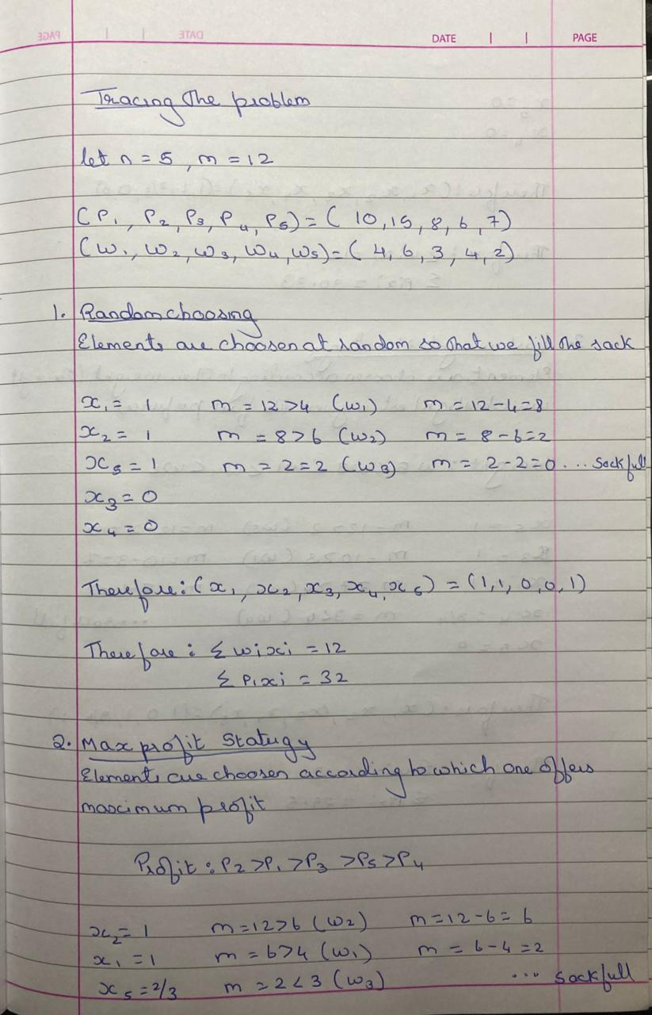

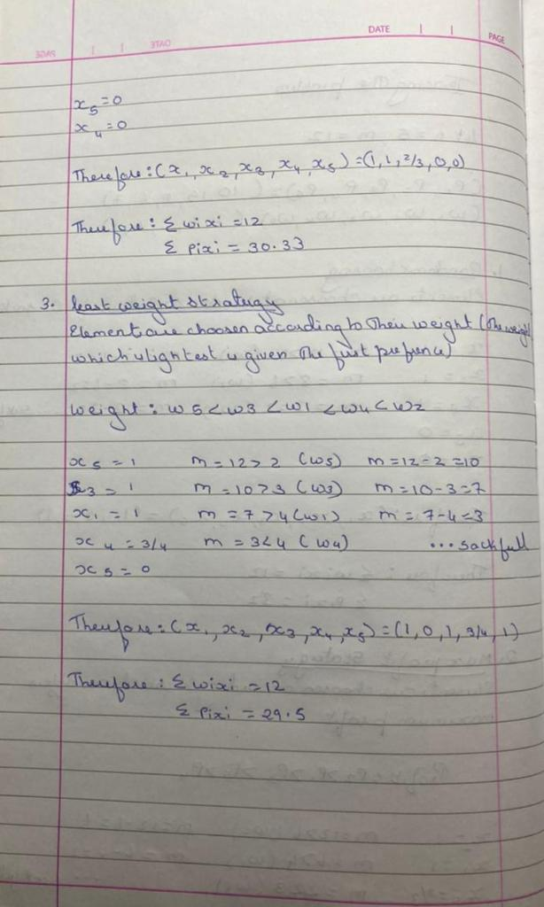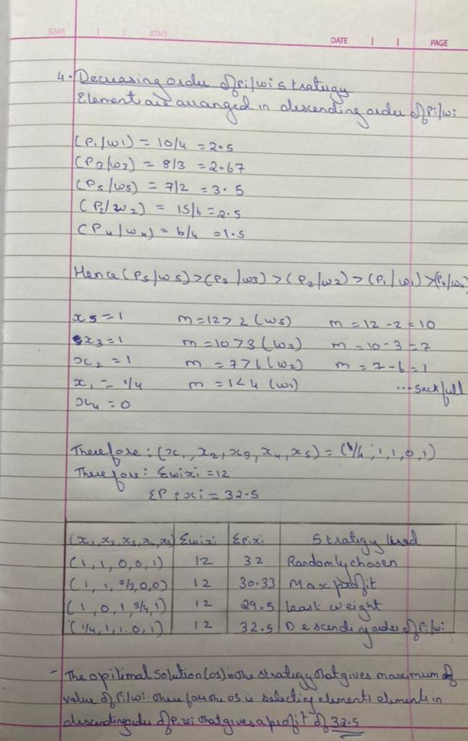

**CODE**

#include<iostream>

using namespace std;

int ctr; float static pr[20], wt[20], x[20];

void GreedyKnapsack(int m, int n)

{

ctr++;

int u=m; ctr++;

float sum=0.0; ctr++;

for(int i=0; i<n; i++)

{

x[i]=0.0; ctr++;

}

ctr++;

int i;

for( i=0; i<n; i++)

{

ctr++;

ctr++;

if(wt[i] > u)

break;

x[i]=1.0; ctr++;

u = u-wt[i]; ctr++;

sum= sum+(pr[i]*x[i]); ctr++;

}

ctr++;

ctr++;

if(i<=n)

{

x[i] = float(u/wt[i]); ctr++;

sum= sum+(pr[i]*x[i]); ctr++;

}

cout<<"\n\n*********************"<<endl;

cout<<"SOLUTION VECTOR: "; ctr++;

for(int i=0; i<n; i++)

{

ctr++;

cout<<x[i]<<" ";ctr++;

}

cout<<"\n*********************"<<endl;

ctr++;

cout<<"\n\n*********************"<<endl;

cout<<"MAXIMUM PROFIT: "<<sum<<endl; ctr++;

cout<<"*********************"<<endl;

ctr++;

}

int main()

{

int n, m;

cout<<"\nENTER NUMBER OF ELEMENTS(n): \n"; ctr++;

cin>>n; ctr++;

cout<<"\nENTER CAPACITY(m): \n"; ctr++;

cin>>m; ctr++;

cout<<"\nENTER PROFITS: "<<"\n"; ctr++;

for(int i=0; i<n; i++)

{

cin>>pr[i]; ctr++;

}

ctr++;

cout<<"\nENTER WEIGHTS: "<<"\n"; ctr++;

for(int i=0; i<n; i++)

{

cin>>wt[i]; ctr++;

}

ctr++;

float ratio[n], temp; ctr++;

for (int i = 0; i < n; i++)

{

ctr++;

ratio[i] = pr[i] / wt[i]; ctr++;

}

ctr++;

for (int i = 0; i < n; i++)

{

ctr++;

for (int j = 0; j < n; j++)

{

ctr++;

ctr++;

if (ratio[j] < ratio[j+1])

{

temp = ratio[j]; ctr++;

ratio[j] = ratio[j+1]; ctr++;

ratio[j+1] = temp; ctr++;

temp = wt[j]; ctr++;

wt[j] = wt[j+1]; ctr++;

wt[j+1] = temp; ctr++;

temp = pr[j]; ctr++;

pr[j] = pr[j+1]; ctr++;

pr[j+1] = temp; ctr++;

}

}

ctr++;

}

ctr++;

cout<<"\nPROFITS: "<<endl; ctr++;

for(int i=0; i<n; i++)

{

ctr++;

cout<<pr[i]<<" ";ctr++;

}

cout<<"\nWEIGHTS: "<<endl; ctr++;

for(int i=0; i<n; i++)

{

ctr++;

cout<<wt[i]<<" ";ctr++;

}

GreedyKnapsack(m, n);

cout<<"\n\n**************"<<endl;

cout<<"STEP COUNT: "<<ctr<<endl;

cout<<"**************"<<endl;

return 0;

}

**OUTPUT**

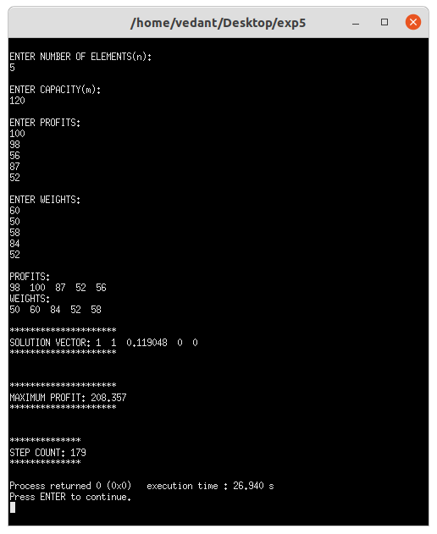

**CONCLUSION**

* Detailed concept of Knapsack Problem (Greedy Method) was studied successfully.
* Knapsack program was executed successfully.
* The step count for the Quick Sort algorithm was obtained